**1.program to write data in a file**

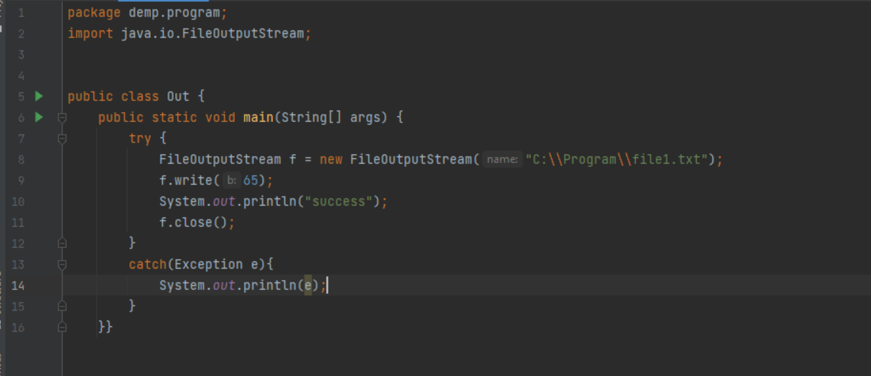

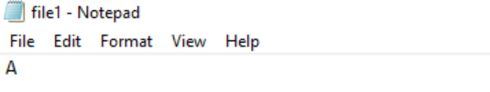

**2.Program for print the first character of a file**

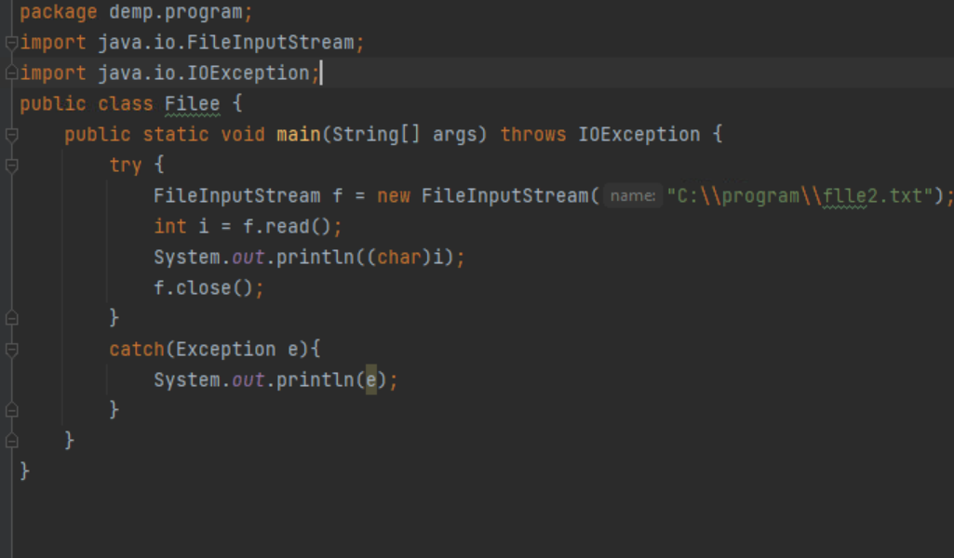

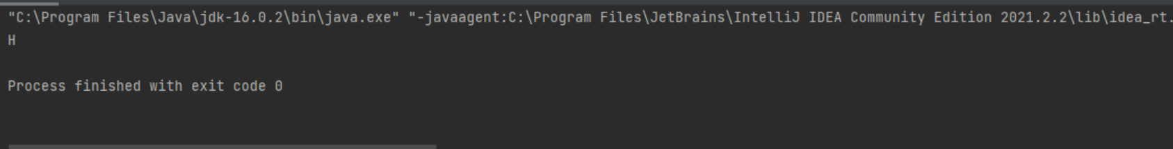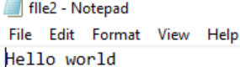

**3.Program to use of flush () method while using BufferedOutputStream also try to write data in a file using BuffereedOutputstream**

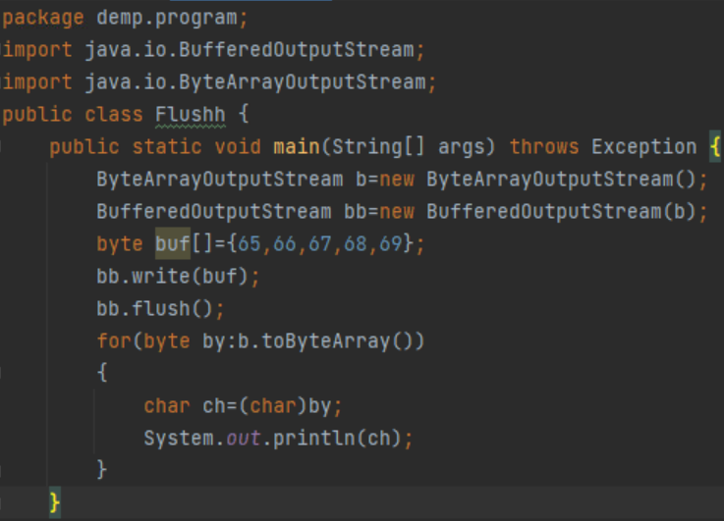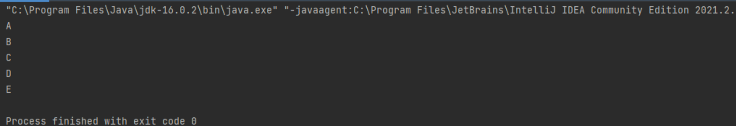

**4. Get the size of buffer using bytearrayoutput stream**

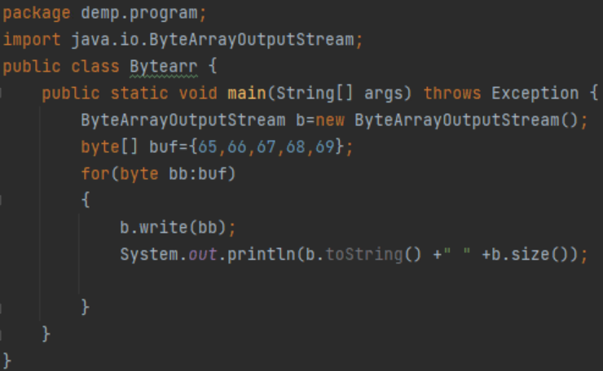

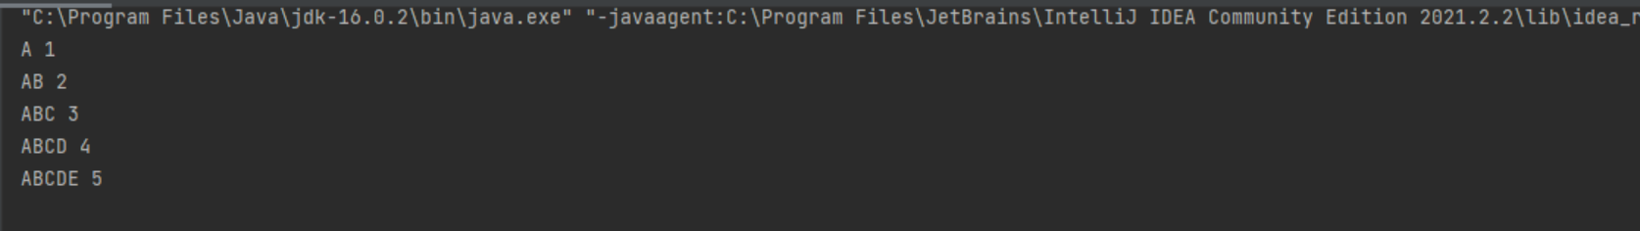

**5.Program to provide read and write permission to a file**

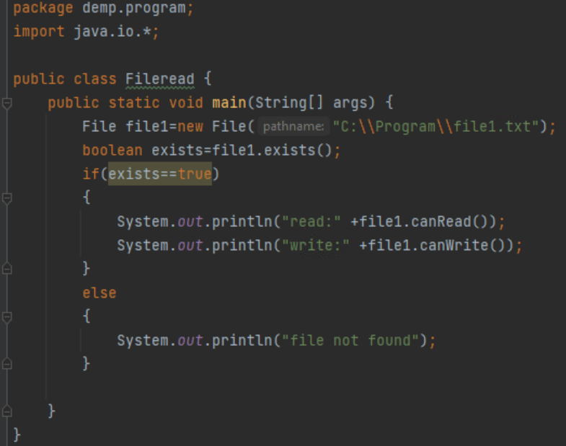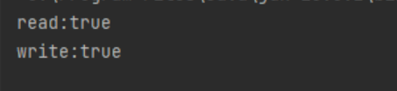

**6.Program to write a data in to a file and the data is I am a java programmer**

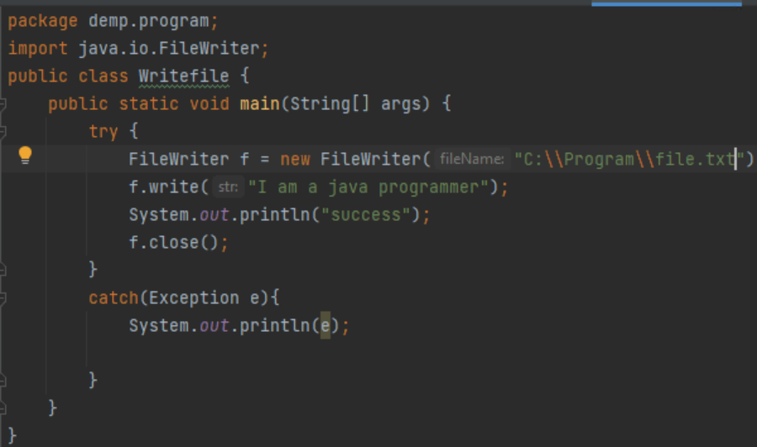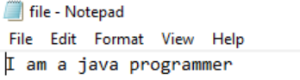

**7. WAP to get the available number of bytes in a file by FileInputStream**

